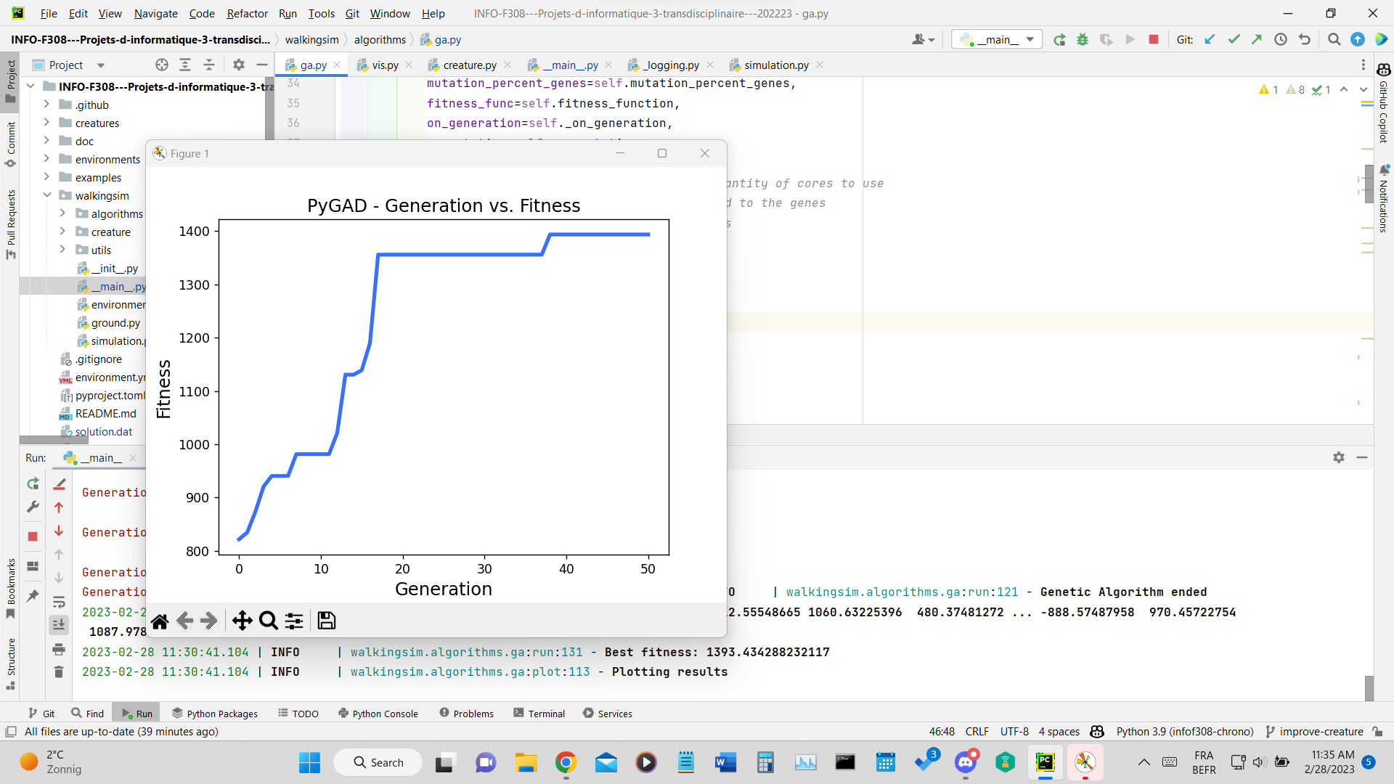

population_size = 100

GA = GeneticAlgorithm(

population_size=population_size,

num_generations=50,

num_parents_mating=4,

mutation_percent_genes=10,

num_joints=4,

parallel_processing=None,

init_range_low=-1000, # init range applied to the genes

# which in this case are the forces/angles

init_range_high=1000,

random_mutation_min_val=-1000,

random_mutation_max_val=1000,

parent_selection_type="tournament",

keep_elitism=population_size // 100,

crossover_type="uniform",

)

